Q1.Saturday, there is a donation party in NTHU EE department, supposed that we invited total n alumni and the probability for each of them to show up is p. The donation from each of alumni is exponential distribution. Find the expectation and variance for total donation.

A1.N: the number of participants

X: the amount of donation for each participants

Y=X1+X2+……+XN

N is Binomial distribution 🡪 E[N]=np Var(N)=np(1-p)

X is exponential distribution 🡪 E[X]=1/λ Var(X)=1/ ${}^{2}$

E[Y]=E[E[Y|N]]=E[NE[X]]=E[N]E[X]=np/λ

Var(Y)=E[Var(Y|N)]+Var(E[Y|N])=E[NVar(X)]+Var(NE[X])

=Var(X)E[N]+Var(N) ${(E[X])}^{2}$

=np/ ${}^{2}$ +np(1-p)/ ${}^{2}$ =np(2-p)/ ${}^{2}$

Q2. Prove that if θ is a random number from the interval [0,2π], then the dependent

random variable X=sinθ and Y=cosθ are uncorrelated

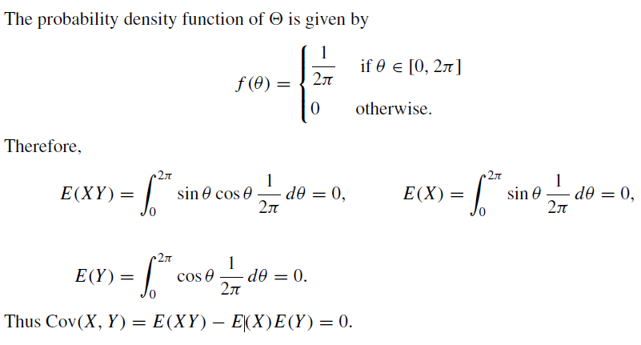

Q3. Suppose we have an integer valued random variable X having the moment generating function shown below

$$M_{X}(s)=\frac{e^{s}}{3-e^{3s}-e^{4s}}$$

Find the $E[X]$

Find $P\left\{X=5\right\}$

Hint : Use Maclaurin’s series of $\frac{1}{1-x}$

Solution:

1.

$$M_{X}(s)=\frac{e^{s}}{3-e^{3s}-e^{4s}}$$

$$∴(3-e^{3s}-e^{4s})M_{X}(s)=e^{s}$$

Differentiate both sides

$$\left(-3e^{3s}-4e^{4s}\right)M_{X}\left(s\right) + (3-e^{3s}-e^{4s})M_{X}^{'}(s)=e^{s}$$

Plug in $s=0$

$E\left[X\right]=M_{X}^{'}\left(0\right)=8$

2.

$$\frac{e^{s}}{3-e^{3s}-e^{4s}}=\frac{1}{3}\left(\frac{e^{s}}{1-\frac{1}{3}(e^{3s}+e^{4s})}\right)$$

$$=\frac{1}{3}e^{s}\left(1+\frac{1}{3}\left(e^{3s}+e^{4s}\right)+\frac{1}{9}{(e^{3s}+e^{4s})}^{2}+…\right)$$

$$=\frac{1}{3}e^{s}+\frac{1}{9}e^{4s}+\frac{1}{9}e^{5s}+…$$

$$∴P\left\{X=5\right\}=\frac{1}{9}$$

Q4.

Let x, y, z be three independent random variables uniformly distributed in [0,1], what’s the PDF of x>=yz?

Answer: 

Q5.

Suppose that a random variable X satisfies

$$E\left[X\right]=0, E\left[X^{2}\right]=1, E\left[X^{3}\right]=0, E\left[X^{4}\right]=3$$

And let

$$Y=a+bX+cX^{2}$$

Find the correlation coefficient $ρ(X. Y)$

Answer:

$$ρ(X,Y ) =\frac{cov(x,y)}{σXσY}$$

$$cov\left(X,Y \right)= E\left[XY \right]-E\left[X\right]E\left[Y \right]$$

$$= E\left[aX + bX^{2} + cX^{3}\right]-E\left[X\right]E\left[Y \right]$$

$$= aE[X] + bE[X^{2}] + cE[X^{3}]$$

$$= b.$$

$$var\left(Y \right)= var\left(a + bX + cX^{2}\right)= E[{\left(a + bX + cX^{2}\right)}^{2}]-{(E\left[a + bX + cX^{2}\right])}^{2} = \left(a^{2} + 2ac + b^{2} + 3c^{2}\right)-\left(a^{2} + c^{2} + 2ac\right)$$

$$= b2 + 2c2$$

$$var(X) = 1,$$

$$ρ(X,Y ) =\frac{b}{\sqrt{b^{2}+2c^{2}}}$$